CAM937 Research Methods. Statistics Project
Group 2: Rachel Nelan (DL), Wai Kei Valerie Suen, Eylul Turkay, Aayah Al-Hammdany, Isla Howlett

Title: Evaluating Differences in Consumer Taste Ratings and Perceptions between Supermarket Own-Brand and Well-known Brand Orange Juice
Introduction
Orange juice is one of the most widely consumed fruit beverages globally (GIS, 2025) and is available in both branded and supermarket-own brand versions. Consumer preference is often influenced by sensory perceptions, as these critically affect liking and choice, including sweetness, aroma, acidity, mouthfeel and aftertaste. These attributes influence buying decisions and overall liking (Kim et al.,2013). Additionally, previous research in food science suggests that brand awareness can bias taste perceptions, sometimes leading customers to rate branded products more favourably.
However, there is limited rigorous, blinded sensory evaluation focused specifically on orange juice (Bi et al., 2015). This provides an opportunity to investigate whether people can truly taste the difference between orange juices, or if their preferences are mainly influenced by the brand (Gao et al., 2024)
This study aims to compare taste perceptions and preferences between Sainsbury’s own-brand and Tropicana orange juice under blinded conditions. Participants will rate sensory attributes and overall liking. Additionally, the study will assess if revealing brand identities after tasting affects participants' choices, thereby exploring the role of brand awareness in shaping taste judgements. By analysing participants’ ratings and comments on key flavour attributes, this research seeks to determine the relationship between sensory experience, brand expectation and final preference.

Method
A within-subject blinded study design was used to compare sensory ratings between two orange juice samples, where participants did not know which sample was which to prevent bias. Each participant evaluated both samples independently, allowing paired statistical analysis. The study was conducted at Barts Cancer Institute between 23-30/10/25. A voluntary sampling approach was employed, recruiting 120 adult participants from the institute. Eligibility was confirmed through a brief screening form, and all participants provided informed consent by ticking a consent box after reading the information sheet (Appendix A). Data was anonymised, and no personal identifiers were recorded.
Of the 120 participants recruited, two were excluded entirely from the statistical analysis due to incomplete or invalid responses: one participant had no overall rating for sample B, and another recorded both A and B as preferences. A further single participant did not specify whether their preference changed after brand reveal and was therefore excluded only from preference-change analysis. This resulted in 118 valid paired observations for sensory rating comparisons and 117 valid responses for preference-based analysis.
A questionnaire was used to collect ratings for each sample (Appendix B). Participants rated both orange juices using a structured questionnaire (Appendix B) designed to assess overall liking, sensory attributes and the effect of brand awareness The questionnaire included several components: participants rated overall liking on a 5-point scale (1=dislike very much, 5=like very much), selected the primary reason for liking or disliking from five key sensory attributes (sweetness, aroma, acidity, mouthfeel, aftertaste) and provided individual ratings of each attribute on the same 5-point scale (1=very low/poor, 5=very high/excellent). After the blind tasting, participants indicated which sample they preferred before the brand reveal and then indicated whether their preference changed once the brand identity was disclosed.
Two commercially available orange juice samples were used: Sainsbury’s Taste the Difference Smooth and Tropicana Smooth Orange juice. Each participant received 25ml of each sample, served at room temperature, in an identical paper cup labelled ‘A’ or ‘B’ to ensure blinding. Water was provided for palate cleansing between tastings.
Data analysis was primarily conducted in R Studio and confirmed with SPSS to test the study hypotheses. The primary hypothesis examined whether there was an association in taste ratings between supermarket-owned brand (Sainsbury’s Taste The Difference) and well-known brand (Tropicana). The null hypothesis (H₀) stated that there is no difference between the taste ratings of the two juices, while the alternative hypothesis (H₁) Tropicana will have a higher mean taste rating than Sainsbury’s Taste the Difference. The secondary hypothesis explored whether the knowledge of brand identity influenced the participants’ preferences. The null hypothesis proposed no association between knowledge of orange juice brand and juice preference, whereas the alternative hypothesis proposed an association between the two.
To test these hypotheses, data were first assessed for normality using the Shapiro-Wilk test, which confirmed significant deviation from a normal distribution (p <0.001) across all variables, ranging from 1.23×10⁻⁸ to 1.12×10⁻⁶. Consequently, the non-parametric test of the Wilcoxon signed-rank test was used to compare the sensory attribute ratings between the two samples. Fisher’s Exact test was used to test whether the knowledge of brand identity was associated with preference change after the reveal. The descriptive statistics of overall liking scores for both juices were provided. Furthermore, a box plot was generated to visualise the distribution of overall liking scores for both juices, illustrating differences in participants' ratings between samples A and B. In this study, statistical significance was accepted when p≤ 0.05.

Results
The dataset consisted of overall liking ratings for juice A and B. Each participant evaluated both samples independently, resulting in paired observations from the same individual. According to Figure 1, Juice A received slightly higher ratings (mean 3.49, median 3.5), compared to juice B (mean 3.11, median 3.0). The distribution of juice A was more concentrated, with scores ranging from 1 to 5, IQR 3 to 4. While juice B showed similar range, but a lower median and wider variability (IQR 2 to 4). Overall, the box plot shows that participants prefer juice A marginally more than juice B.
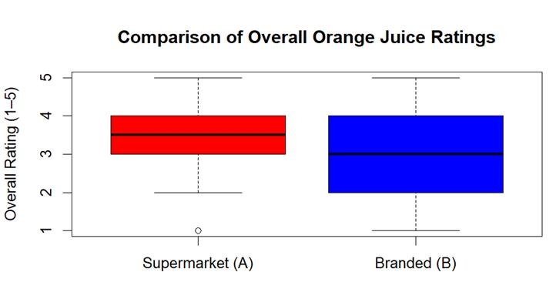
Figure 1. Box plot comparing overall liking scores for Sainsbury’s Taste the Difference Smooth Orange Juice (supermarket own-brand) (red) and Tropicana Smooth Orange Juice (branded) (blue). Attributes (sweetness, aroma, acidity, mouthfeel, aftertaste) were rated on a scale of 1-5 (1=dislike very much, 5=like very much). The boxes represent interquartile range (IQR), the horizontal line shows the median and whiskers show the full range of responses.
As shown in Table 1, the Wilcoxon signed-rank test indicated significant differences between the two orange juices for overall liking, aroma, acidity, mouthfeel and aftertaste, all favouring the supermarket brand (Sample A). Statistically significant differences were observed for overall rating, aroma, acidity, mouthfeel and aftertaste, while sweetness showed no significant difference (p-value = 0.149 > 0.05). All results favoured supermarket juice A.

Table 1. Data obtained from the Wilcoxon test comparing participants’ ratings for each attribute.
Attribute | Mean ± SD (Supermarket A) | Mean ± SD (Branded B) | Z statistic | p-value*
Overall Rating | 3.49 ± 1.08 | 3.11 ± 1.12 | −0.17 | 0.017
Sweetness | 3.22 ± 1.16 | 3.44 ± 1.14 | −4.21 | 0.149
Aroma | 3.47 ± 1.09 | 3.01 ± 1.11 | −2.69 | 0.002
Acidity | 3.70 ± 1.12 | 2.56 ± 1.08 | 2.58 | 0.000
Mouthfeel | 3.67 ± 1.06 | 3.03 ± 1.19 | −1.90 | 0.000
Aftertaste | 3.62 ± 1.12 | 3.03 ± 1.32 | −1.02 | 0.000
*Wilcoxon-signed rank test

Fisher’s Exact Test was performed to assess whether there was an association between preference change and juice preference following the brand reveal. Out of 120 participants, only 5 participants reported a change in their preference after the brand reveal. Fisher’s Exact Test and Chi-square analysis both indicated no association between preference change and juice preference (Fisher’s: p = 0.391, odds ratio = 0.324; Chi-square = 0.346, df = 1, p = 0.556). However, the chi-square output generated a warning suggesting that the approximation may be unreliable due to low expected frequencies, as the expected cell count for each group should be at least five (Abdul Rahman et al., 2025). Therefore, Fisher’s Exact test was considered more appropriate for this dataset, confirming that knowledge of brand identity did not affect the participants’ preferences. Collectively, these findings suggest that while the sweetness rating did not differ between juices, the supermarket sample was rated significantly higher across other sensory attributes, indicating an overall sensory preference that is independent of brand recognition or expectation bias.

Discussion
This experiment evaluated the differences in consumer taste ratings and perception between supermarket own-brand and well-known brand orange juice, as well as assess if a brand reveal affects the participants choice. According to a previous study investigating consumer preferences, it was shown that brand awareness can influence taste perception, often causing consumers to rate branded products more favorably. While supermarket own-brand products are generally perceived to have lower intrinsic quality compared to well-known branded products, our study does not support this view (Olsen et al., 2011). Our results indicate that the supermarket sample was favored over the well-known branded orange juice.
While this study provides insight into consumer perception of orange juice quality, several limitations should be acknowledged. We minimised bias, for example, by using plain cups to conceal branding and providing water between tastings to cleanse the palate. Despite these controls, the study used a non-random sample, which may reduce the extent to which the findings can be generalised to the wider population, as all participants were recruited from a single institution, potentially introducing demographic bias. Additionally, the supermarket product tested was from a premium ‘Taste the Difference’ range, which may not accurately reflect the sensory profile of lower-cost supermarket alternatives, thereby narrowing the comparative scope.

Methodologically, sensory perception is subjective, and some participants may have interpreted overlapping attributes such as sweetness and aroma differently, affecting response consistency. The lack of colour blinding could also have introduced bias, as visual cues are known to influence taste perception and preference formation (Motoki, Spence and Velasco, 2023). Furthermore, order effects and carry-over effects may have occurred, since sample presentation was not randomised between participants (sample A was always given before sample B). From a statistical standpoint, the small number of participants who changed their preference after brand reveal prevented use of the chi-square test, necessitating the Fisher’s exact test, which is better suited for small sample sizes. However, with a larger cohort, more robust inferable analysis could be conducted to confirm these findings.

Future studies should aim to expand sample diversity and size, include randomised tasting orders, and implement colour-masking to eliminate visual bias. Comparing a wider range of brands, including budget supermarket juices, may offer a more representative assessment of consumer perception. Additionally, incorporating quantitative analyses of the juice composition (e.g., sugar or acid content) could link objective measures of sweetness or acidity to subjective ratings, strengthening interpretation of sensory data. Testing the effect of temperature on flavour perception could also provide further insight into environmental influences on consumer preference.

References

- Motoki K, Spence C, Velasco C. When visual cues influence taste/flavour perception: A systematic review. Food Quality and Preference [Internet]. 2023 Oct 1;111(111):104996.
- Kim MK, Lee YJ, Kwak HS, Kang MW. Identification of sensory attributes that drive consumer liking of commercial orange juice products in Korea. J Food Sci. 2013 Sep;78(9):S1451-8. doi: 10.1111/1750-3841.12227. Epub 2013 Aug 2. PMID: 23909609.
- Bi, X., Gao, Z., House, L. A., & Hausmann, D. S. (2015). Tradeoffs between sensory attributes and organic labels: The case of orange juice. International Journal of Consumer Studies, 39(2), 162–171.
- Gao, F., Li, X., Chen, Y., and Zhang, J. (2024). Sensory brand experience and brand loyalty: Mediators and mechanisms. Acta Psychologica, 244, 104191

Abdul Rahman, H., Noraidi, ⁠Amirul Ariffin, Hj Khalid, ⁠Amal Nadhirah, Mohamad-Adam, ⁠Alanna Zawani, Zahari, N.H. & Tuming, N.E. (2025) Practical guide to calculate sample size for chi-square test in biomedical research. BMC Medical Research Methodology. 25. doi:10.1186/s12874-025-02584-4.

Group member evaluation:
- Rachel: Project idea, drafted original consent form and participants' information sheet, organised recruitment of BCI participants, bought materials, collected and recorded data. Introduction and method, R, and final editing.
- Eylul: Editing project idea and consent form and participants' information sheet, recruited participants, collected and recorded data, R coding and statistical analysis, final editing.
- Isla: Editing project idea and consent form and participants' information sheet, recruited participants, bought materials, collected and recorded data, writing discussion, R, final editing.
- Aayah: Editing project idea and consent form and participants' information sheet, recruited participants, collected and recorded data, writing discussion, R, final editing.
- Valerie: Editing project idea and consent form and participants' information sheet, recruited participants, bought materials, collected and recorded data, R and statistical analysis, and final editing.

Appendix A
Participants' form and consent form
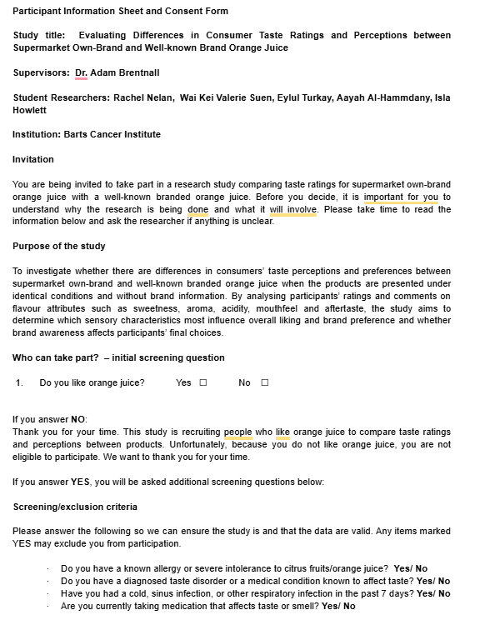


Appendix B
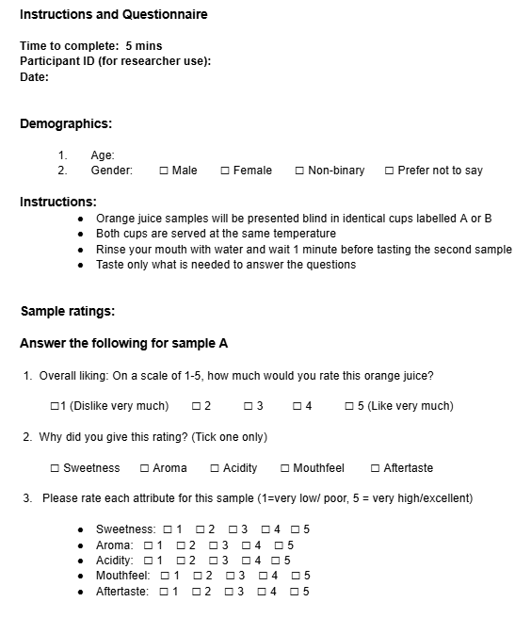
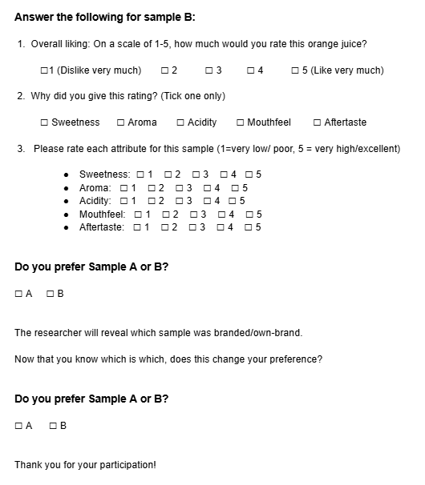

Appendix C
Save the dataset as “data” when the excel file is imported to R studio.
library(ggplot2)
library(readxl)
library(dplyr)
library(tidyr)
str(data)
wilcox.test(data$`Overall Rating of SA`, data$`Overall Rating of SB`, paired = TRUE)
wilcox.test(data$`Sweetness SA`, data$`Sweetness SB`, paired = TRUE)
wilcox.test(data$`Aroma SA`, data$`Aroma SB`, paired = TRUE)
wilcox.test(data$`Acidity SA`, data$`Acidity SB`, paired = TRUE)
wilcox.test(data$`Mouthfeel SA`, data$`Mouthfeel SB`, paired = TRUE)
wilcox.test(data$`Aftertaste SA`, data$`Aftertaste SB`, paired = TRUE)
shapiro.test(data$`Overall Rating of SA`)
shapiro.test(data$`Overall Rating of SB`)
shapiro.test(data$`Sweetness SA`)
shapiro.test(data$`Sweetness SB`)
shapiro.test(data$`Aroma SA`)
shapiro.test(data$`Aroma SB`)
shapiro.test(data$`Acidity SA`)
shapiro.test(data$`Acidity SB`)
shapiro.test(data$`Mouthfeel SA`)
shapiro.test(data$`Mouthfeel SB`)
shapiro.test(data$`Aftertaste SA`)
shapiro.test(data$`Aftertaste SB`)
table_pref <- table(data$`Preference`, data$`Preference Change`)
fisher.test(table_pref)
chisq.test(table_pref)
boxplot(data$`Overall Rating of SA`, data$`Overall Rating of SB`,
names = c("Supermarket (A)", "Branded (B)"),
col = c("red", "blue"),
main = "Comparison of Overall Orange Juice Ratings",
ylab = "Overall Rating (1–5)")
summary(data$`Overall Rating of SA`)
summary(data$`Overall Rating of SB`)
install.packages("rmarkdown")
library(rmarkdown)
attributes <- c("Overall Rating of", "Sweetness", "Aroma", "Acidity", "Mouthfeel", "Aftertaste")
display_names <- c("Overall Rating", "Sweetness", "Aroma", "Acidity", "Mouthfeel", "Aftertaste")

results <- data.frame(
Attribute = character(),
Mean_SD_A = character(),
Mean_SD_B = character(),
Z_statistic = numeric(),
p_value = numeric(),
stringsAsFactors = FALSE
)

for (i in seq_along(attributes)) {
att <- attributes[i]
label <- display_names[i]

varA <- paste(att, "SA")
varB <- paste(att, "SB")

x <- as.numeric(data[[varA]])
y <- as.numeric(data[[varB]])

meanA <- mean(x, na.rm = TRUE)
sdA <- sd(x, na.rm = TRUE)
meanB <- mean(y, na.rm = TRUE)
sdB <- sd(y, na.rm = TRUE)

test <- wilcox.test(x, y, paired = TRUE, exact = FALSE, correct = FALSE)

W <- unname(test$statistic)
n <- sum(!is.na(x) & !is.na(y))
mu <- n * (n + 1) / 4
sigma <- sqrt(n * (n + 1) * (2 * n + 1) / 24)
Z <- (W - mu) / sigma

results <- rbind(
results,
data.frame(
Attribute = label,
Mean_SD_A = paste0(round(meanA, 2), " ± ", round(sdA, 2)),
Mean_SD_B = paste0(round(meanB, 2), " ± ", round(sdB, 2)),
Z_statistic = round(Z, 2),
p_value = round(test$p.value, 3),
stringsAsFactors = FALSE
)
)
}

print(results, row.names = FALSE)

RESULTS
> library(ggplot2)
> library(readxl)
> library(dplyr)

Attaching package: ‘dplyr’

The following objects are masked from ‘package:stats’:

filter, lag

The following objects are masked from ‘package:base’:

intersect, setdiff, setequal, union
> library(tidyr)
> library(readxl)
> data <- read_excel("C:/Users/eylul/OneDrive/Desktop/MSc Molecular and Cancer Pathology and Gneomics/Research Methods/Research Group Project - Participants Data - Sheet4.xlsx",
+ col_types = c("numeric", "numeric", "text",
+ "numeric", "text", "numeric", "numeric",
+ "numeric", "numeric", "numeric",
+ "numeric", "text", "numeric", "numeric",
+ "numeric", "numeric", "numeric",
+ "text", "text"))
> View(data)
> str(data)
tibble [118 × 19] (S3: tbl_df/tbl/data.frame)
$ Participant ID : num [1:118] 1 2 3 4 5 6 7 8 9 10 ...
$ Age : num [1:118] 22 30 38 27 22 NA 43 36 NA 38 ...
$ Gender : chr [1:118] "F" "M" "M" "F" ...
$ Overall Rating of SA: num [1:118] 5 4 3 3 3 4 4 3 5 5 ...
$ Reason for SA Rating: chr [1:118] "Aroma" "Acidity" "Aftertaste" "Acidity" ...
$ Sweetness SA : num [1:118] 4 3 4 4 2 1 4 4 5 4 ...
$ Aroma SA : num [1:118] 5 4 3 3 2 5 2 3 4 4 ...
$ Acidity SA : num [1:118] 3 5 4 2 3 5 4 3 4 4 ...
$ Mouthfeel SA : num [1:118] 4 3 2 3 2 5 4 2 4 4 ...
$ Aftertaste SA : num [1:118] 4 4 2 5 3 3 3 2 1 4 ...
$ Overall Rating of SB: num [1:118] 3 3 4 4 4 4 2 2 3 3 ...
$ Reason for SB Rating: chr [1:118] "Sweetness" "Sweetness" "Mouthfeel" "Acidity" ...
$ Sweetness SB : num [1:118] 4 4 4 4 3 4 2 2 3 3 ...
$ Aroma SB : num [1:118] 2 2 3 3 4 1 2 1 3 2 ...
$ Acidity SB : num [1:118] 3 3 4 4 3 3 2 2 3 2 ...
$ Mouthfeel SB : num [1:118] 3 3 4 4 4 1 2 1 4 2 ...
$ Aftertaste SB : num [1:118] 2 3 4 4 4 1 2 1 3 1 ...
$ Preference : chr [1:118] "A" "A" "B" "B" ...
$ Preference Change : chr [1:118] "No" "No" "No" "No" ...
> wilcox.test(data$`Overall Rating of SA`, data$`Overall Rating of SB`, paired = TRUE)

Wilcoxon signed rank test with continuity correction

data: data$`Overall Rating of SA` and data$`Overall Rating of SB`
V = 3446.5, p-value = 0.01723
alternative hypothesis: true location shift is not equal to 0

> wilcox.test(data$`Sweetness SA`, data$`Sweetness SB`, paired = TRUE)

Wilcoxon signed rank test with continuity correction

data: data$`Sweetness SA` and data$`Sweetness SB`
V = 1942.5, p-value = 0.1492
alternative hypothesis: true location shift is not equal to 0

> wilcox.test(data$`Aroma SA`, data$`Aroma SB`, paired = TRUE)

Wilcoxon signed rank test with continuity correction

data: data$`Aroma SA` and data$`Aroma SB`
V = 2508.5, p-value = 0.002351
alternative hypothesis: true location shift is not equal to 0

> wilcox.test(data$`Acidity SA`, data$`Acidity SB`, paired = TRUE)

Wilcoxon signed rank test with continuity correction

data: data$`Acidity SA` and data$`Acidity SB`
V = 4471.5, p-value = 6.877e-11
alternative hypothesis: true location shift is not equal to 0

> wilcox.test(data$`Mouthfeel SA`, data$`Mouthfeel SB`, paired = TRUE)

Wilcoxon signed rank test with continuity correction

data: data$`Mouthfeel SA` and data$`Mouthfeel SB`
V = 2803.5, p-value = 4.329e-05
alternative hypothesis: true location shift is not equal to 0

> wilcox.test(data$`Aftertaste SA`, data$`Aftertaste SB`, paired = TRUE)

Wilcoxon signed rank test with continuity correction

data: data$`Aftertaste SA` and data$`Aftertaste SB`
V = 3129, p-value = 0.0005935
alternative hypothesis: true location shift is not equal to 0

> wilcox.test(data$`Mouthfeel SA`, data$`Mouthfeel SB`, paired = TRUE)

Wilcoxon signed rank test with continuity correction

data: data$`Mouthfeel SA` and data$`Mouthfeel SB`
V = 2803.5, p-value = 4.329e-05
alternative hypothesis: true location shift is not equal to 0

> wilcox.test(data$`Acidity SA`, data$`Acidity SB`, paired = TRUE)

Wilcoxon signed rank test with continuity correction

data: data$`Acidity SA` and data$`Acidity SB`
V = 4471.5, p-value = 6.877e-11
alternative hypothesis: true location shift is not equal to 0

> wilcox.test(data$`Aroma SA`, data$`Aroma SB`, paired = TRUE)

Wilcoxon signed rank test with continuity correction

data: data$`Aroma SA` and data$`Aroma SB`
V = 2508.5, p-value = 0.002351
alternative hypothesis: true location shift is not equal to 0

> wilcox.test(data$`Sweetness SA`, data$`Sweetness SB`, paired = TRUE)

Wilcoxon signed rank test with continuity correction

data: data$`Sweetness SA` and data$`Sweetness SB`
V = 1942.5, p-value = 0.1492
alternative hypothesis: true location shift is not equal to 0

> wilcox.test(data$`Overall Rating of SA`, data$`Overall Rating of SB`, paired = TRUE)

Wilcoxon signed rank test with continuity correction

data: data$`Overall Rating of SA` and data$`Overall Rating of SB`
V = 3446.5, p-value = 0.01723
alternative hypothesis: true location shift is not equal to 0

> shapiro.test(data$`Overall Rating of SA`)

Shapiro-Wilk normality test

data: data$`Overall Rating of SA`
W = 0.89945, p-value = 2.227e-07

> shapiro.test(data$`Overall Rating of SB`)

Shapiro-Wilk normality test

data: data$`Overall Rating of SB`
W = 0.90526, p-value = 4.435e-07

> shapiro.test(data$`Overall Rating of SA`)

Shapiro-Wilk normality test

data: data$`Overall Rating of SA`
W = 0.89945, p-value = 2.227e-07

> shapiro.test(data$`Overall Rating of SB`)

Shapiro-Wilk normality test

data: data$`Overall Rating of SB`
W = 0.90526, p-value = 4.435e-07

> shapiro.test(data$`Sweetness SA`)

Shapiro-Wilk normality test

data: data$`Sweetness SA`
W = 0.89712, p-value = 1.701e-07

> shapiro.test(data$`Sweetness SB`)

Shapiro-Wilk normality test

data: data$`Sweetness SB`
W = 0.90193, p-value = 2.98e-07

> shapiro.test(data$`Aroma SA`)

Shapiro-Wilk normality test

data: data$`Aroma SA`
W = 0.90071, p-value = 2.58e-07

> shapiro.test(data$`Aroma SB`)

Shapiro-Wilk normality test

data: data$`Aroma SB`
W = 0.91273, p-value = 1.115e-06

> shapiro.test(data$`Acidity SA`)

Shapiro-Wilk normality test

data: data$`Acidity SA`
W = 0.8727, p-value = 1.227e-08

> shapiro.test(data$`Acidity SB`)

Shapiro-Wilk normality test

data: data$`Acidity SB`
W = 0.90307, p-value = 3.408e-07

> shapiro.test(data$`Mouthfeel SA`)

Shapiro-Wilk normality test

data: data$`Mouthfeel SA`
W = 0.88156, p-value = 3.065e-08

> shapiro.test(data$`Mouthfeel SB`)

Shapiro-Wilk normality test

data: data$`Mouthfeel SB`
W = 0.91128, p-value = 9.29e-07

> shapiro.test(data$`Aftertaste SB`)

Shapiro-Wilk normality test

data: data$`Aftertaste SB`
W = 0.90523, p-value = 4.419e-07

> table_pref <- table(data$`Preference`, data$`Preference Change`)
> fisher.test(table_pref)

Fisher's Exact Test for Count Data

data: table_pref
p-value = 0.3911
alternative hypothesis: true odds ratio is not equal to 1
95 percent confidence interval:
0.006403403 3.412185080
sample estimates:
odds ratio
0.3241372

> chisq.test(table_pref)

Pearson's Chi-squared test with Yates' continuity
correction

data: table_pref
X-squared = 0.34615, df = 1, p-value = 0.5563

Warning message:
In chisq.test(table_pref) : Chi-squared approximation may be incorrect

> boxplot(data$`Overall Rating of SA`, data$`Overall Rating of SB`,
+ names = c("Supermarket (A)", "Branded (B)"),
+ col = c("red", "blue"),
+ main = "Comparison of Overall Orange Juice Ratings",
+ ylab = "Overall Rating (1–5)")
> boxplot(data$`Overall Rating of SA`, data$`Overall Rating of SB`,
+ names = c("Supermarket (A)", "Branded (B)"),
+ col = c("red", "blue"),
+ main = "Comparison of Overall Orange Juice Ratings",
+ ylab = "Overall Rating (1–5)")
> points(x = c(1, 2),
+ y = c(mean(data$`Overall Rating of SA`, na.rm = TRUE),
+ mean(data$`Overall Rating of SB`, na.rm = TRUE)),
+ col = "red", pch = 19)
> boxplot(data$`Overall Rating of SA`, data$`Overall Rating of SB`,
+ names = c("Supermarket (A)", "Branded (B)"),
+ col = c("red", "blue"),
+ main = "Comparison of Overall Orange Juice Ratings",
+ ylab = "Overall Rating (1–5)")
> summary(data$`Overall Rating of SA`)
Min. 1st Qu. Median Mean 3rd Qu. Max.
1.000 3.000 3.500 3.492 4.000 5.000
> summary(data$`Overall Rating of SB`)
Min. 1st Qu. Median Mean 3rd Qu. Max.
1.00 2.00 3.00 3.11 4.00 5.00

> attributes <- c("Overall Rating of", "Sweetness", "Aroma", "Acidity", "Mouthfeel", "Aftertaste")
> display_names <- c("Overall Rating", "Sweetness", "Aroma", "Acidity", "Mouthfeel", "Aftertaste")
>
> results <- data.frame(
+ Attribute = character(),
+ Mean_SD_A = character(),
+ Mean_SD_B = character(),
+ Z_statistic = numeric(),
+ p_value = numeric(),
+ stringsAsFactors = FALSE
+ )
>
> for (i in seq_along(attributes)) {
+ att <- attributes[i]
+ label <- display_names[i]
+
+ varA <- paste(att, "SA")
+ varB <- paste(att, "SB")
+
+ x <- as.numeric(data[[varA]])
+ y <- as.numeric(data[[varB]])
+
+ meanA <- mean(x, na.rm = TRUE)
+ sdA <- sd(x, na.rm = TRUE)
+ meanB <- mean(y, na.rm = TRUE)
+ sdB <- sd(y, na.rm = TRUE)
+
+ test <- wilcox.test(x, y, paired = TRUE, exact = FALSE, correct = FALSE)
+
+ W <- unname(test$statistic)
+ n <- sum(!is.na(x) & !is.na(y))
+ mu <- n * (n + 1) / 4
+ sigma <- sqrt(n * (n + 1) * (2 * n + 1) / 24)
+ Z <- (W - mu) / sigma
+
+ results <- rbind(
+ results,
+ data.frame(
+ Attribute = label,
+ Mean_SD_A = paste0(round(meanA, 2), " ± ", round(sdA, 2)),
+ Mean_SD_B = paste0(round(meanB, 2), " ± ", round(sdB, 2)),
+ Z_statistic = round(Z, 2),
+ p_value = round(test$p.value, 3),
+ stringsAsFactors = FALSE
+ )
+ )
+ }
>
> print(results, row.names = FALSE)
Attribute Mean_SD_A Mean_SD_B Z_statistic p_value
Overall Rating 3.49 ± 1.08 3.11 ± 1.12 -0.17 0.017
Sweetness 3.22 ± 1.16 3.44 ± 1.14 -4.21 0.149
Aroma 3.47 ± 1.09 3.01 ± 1.11 -2.69 0.002
Acidity 3.7 ± 1.12 2.56 ± 1.08 2.58 0.000
Mouthfeel 3.67 ± 1.06 3.03 ± 1.19 -1.90 0.000
Aftertaste 3.62 ± 1.12 3.03 ± 1.32 -1.02 0.001
> View(results)

Appendix D
Participants Data

